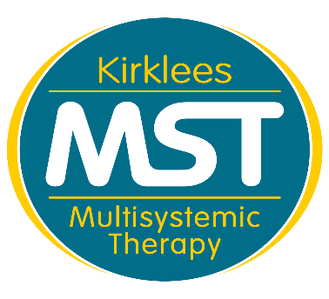
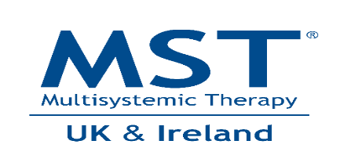
MST Referral Form
Referrer Details
Name of Referrer:
Referrer Role:
Referrer organisation and contact number:
Referrer Email:
Date of Referral:
Details of child/young person
Name of Child:
K Number:
DOB:
Details of primary Caregiver/s
Name of Caregiver/s:
Telephone Number:

Suitability Checklist | Yes | No
Is the young person between 10 and 17 years old and of high school age? | ☐ | ☐
Does the young person live at home? | ☐ | ☐
Does he/she display two or more of the following behaviours:
(If no, MST would not be suitable for the family)
Criminal offending | ☐ | ☐
Anti-social behaviour and/or associating with antisocial peers | ☐ | ☐
Physical aggression | ☐ | ☐
Verbal aggression | ☐ | ☐
Property damage | ☐ | ☐
Suitability Checklist | Yes | No
School exclusion | ☐ | ☐
Behavioural issues at school | ☐ | ☐
Non-attendance/truancy | ☐ | ☐
Running away | ☐ | ☐
Missing from home | ☐ | ☐
CSE/CCE risks | ☐ | ☐
Self-harm | ☐ | ☐
Drug use | ☐ | ☐
Alcohol use | ☐ | ☐
Is the young person at risk of/will be at risk of care, custody/court, out of home placement, or residential school if the behaviour escalates/does not make progress?  (If no, please contact MST to discuss suitability on 01484 414940 | ☐ | ☐
Would the goals of treatment be to reduce parental abuse or neglect? | ☐ | ☐
Are the challenging behaviours caused by the young person’s mental health problems? | ☐ | ☐
Is sexual offending the primary anti-social behaviour shown by the young person? | ☐ | ☐
Is the young person actively suicidal? Homicidal? Actively psychotic? | ☐ | ☐
Is the young person/family involved in another on-going intensive intervention? If Yes, who? | ☐ | ☐
Are you concerned about the caregiver’s motivation to do an intensive intervention? | ☐ | ☐
Open to FGC: | ☐ | ☐

Consent | Yes | No
Has the Caregiver given their consent to be contacted by MST to arrange and complete a suitability assessment? | ☐ | ☐
Has the Caregiver given their consent for Kirklees MST to share any relevant personal data or information about their family with professionals, key people or agencies as part of the MST treatment process? | ☐ | ☐
Please send the completed referral form to MST@kirklees.gov.uk
If you have any queries regarding this form, please contact MST on 01484 414940

