Attendee feedback
- What did you really like about today's event?
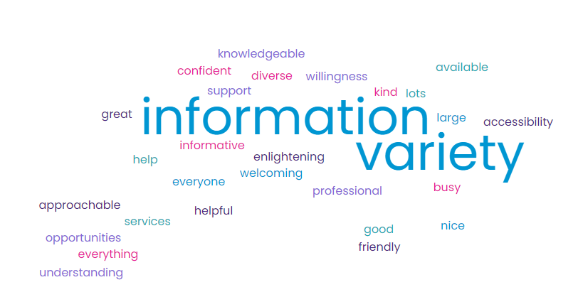

- It was nice to be able to have sessions to select from that give practical advice. A large selection of stalls.
- I liked all the stalls. It was enlightening to learn all what was available.
- So much to offer lots of social groups and support
- Lots of stalls and great variety. everyone was welcoming
- Information about services i wasn’t aware of
- information about all the different services on offer
- lots of very relevant information to my sons needs
- Lots of different people with lots of different information
- How approachable people where.
- the accessibility and number of services available was fab. Good to know there is so much support out there. everyone was really friendly and approachable,
- Being able to speak face to face with services that can help
- a great selection of providers and advisors all really helpful and informative
- The information and how kind everyone was
- as a parent of a child awaiting on answers to some questions today has helped me feel confident and not alone and that i can find solutions
- Location/access and the people on hand to help
- The variety of stalls and information
- The fact is what put on for us to attend. Workshop topics spot on and so many different stalls also
- number of agencies there and knowledge of them and having everyone in one place
- The variety of stalls and information and everything under 1 roof
- So much on offer and lots of friendly faces
- the stalls and provisions
- variety of service providers
- easy to access all support networks able to meet previously
- there is some useful information
- information provided
- lots of different information
- variety of stalls supporting all ages
- access to lots of support and advice
- diverse amount of stall
- meeting sendact face to face learning about new services talking to post16 provisions
- opportunities to see what's available
- lots of people to speak to about worries
- the stalls i visited were very helpful
- the variety of information for all ages and needs
- how informative the event was
- opportunity to meet new support groups and useful workshops
- the opportunity to network and discover a range of services
- lots of good stalls and interesting talks
- the different stalls
- lots of information and different agencies
- very busy event well attended and organised well
- lots of friendly and helpful people with useful information
- very informative and good info received
- lots of information for adults with disabilities very insightful
- putting names to faces
- everything
- the information available
- lots of stalls
- that all services were located in once place aiding accessibility
- lots of variety of support
- lots on offer very informative
- finding out more information on SEND
- lots of information everyone was knowledgeable
- lots of info
- one stop shop
- lots of information
- very helpful
- lots of information and talks
- being able to talk to everyone you need in one place
- the explanations were very helpful
- the amount of stalls, the information was great and benefits workshop very helpful
- being able to speak to people face to face immediately without having to be on hold or have phone calls not answered and also seeing the range of services available.
- really informative
- finding professionals and understanding more
- getting information about services i didnt know about
- information for over 18s
- how busy it was
- loads of opportunities
- i really enjoyed seeing all the different charities
- lots of organisations at the event
- variation of stalls
- speaking to representatives from a variety of support
- good to have an event under one roof and all present put faces to names as only seen online
- workshops interesting and lots of services in one place
- lots of services on offer
- lots of places to get into and always pointed in right direction
- wide range of services and professional but approachable
- so many stalls offering help and support help i didnt even no was about before
- Stalls with feedback opportunities for service i have used
- all resources in one place. People's willingness to direct me to someone else who can help. felt fantastic

- What did you find out that was particularly helpful?
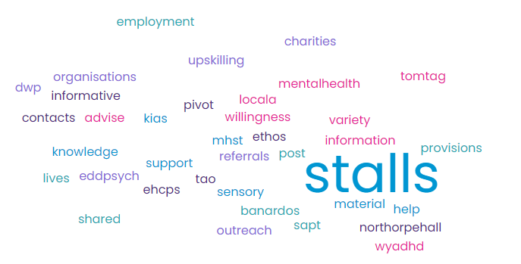
- The sensory OT session was really useful.
- Courses available
- Support that was offered
- material to take away and read at leisure
- The providers
- knowledge of the staff
- Service and groups that will be of use to him
- who can help with what
- Through a friend
- outreach MHST and KIAS stalls where most helpful and TAO activities are really intresting
- northorpe hall and outreach
- educational support plans, home accessibility team and sensory provisions
- EHCPs, Peoples numbers that i have been trying for 10 months in 10 mins
- how informative the staff on stalls where
- NA didnt get my questions answered.
- post 16 opportunities
- services we didn't know existed which is exactly what we needed
- speaking to knowledgeable professionals and been able to talk to multiple agencies in one go
- Sendact, locala sensory stall, kirklees college
- Ethos, piviot other KS4 ideas for my son and activities for both my kids
- a number of useful contacts i can pass on
- able to get all relevant information
- Tom Tag
- the stalls
- giving feedback to the local offer
- where to go for advice for older children into adulthood
- advise for current situation
- information for parents
- post 16 provisions
- sensory and behaviour
- explaining the process about applying for certain help with mental illness
- found a provider who is approved through the adoption support fund
- all stalls visited
- support groups that have children with similar situations and understand processes.
- it was all fab
- young carers banardos
- chatting to people
- early years support
- variety of stalls with useful information
- EHCP/ ADHD and pcan
- info on how to get rid of foreign language at highschool
- the variety of information available
- meeting ability options
- about help for my kids
- as above
- to talk to SAPT
- early years support
- out of school clubs can get 1 to 1 funding and found out about sprouts
- the process of how to start refferals
- speaking with stall holders
- what support is out there
- was nice to talk to sensory team after presentation
- everything in once place
- how to make refferals and where to
- what organisations offer support in kirklees
- communication aids
- the care paln and transition from college to uni
- the services that existed that i wasn't aware off. i have felt badly isolated but there is help if you know where to look
- west yorkshire adhd supoort group is fab
- about what support is available
- EHCP workshop with Ed Psych
- all of it
- shared lived and employment for SEN adults
- lots of contacts and partners to work with
- ADHD and support out there
- i found out about WYADHD partnerships and they have given me lots of help already
- plenty of leaflets to refer to and different providers
- DWP access and support provided and upskilling presentations
- OT, sendact and WYADHD support
- finding out things avalible for our children
- sensory OT
- next steps in terms of making a refferal or seeking support. outreach , MHST CAHMS and TAO amazing
- charities and support for my child
- speaking to various professionals especially the OT
- More knowledge of support groups for parents with SEN children and people's willingness to help

- What do you think we could do to make future events better for you?
- I found the stall area very overwhelming. It was really busy and was difficult to see what was available. Maybe have it in a larger area or separate areas to spread them out to make them more accessible please.
- Some of the workshops felt a bit rushed and some topics in the title weren’t covered. There was no mention of autism in the mental health, anxiety and autism workshop, perhaps slightly longer than 30 mins ?
- Nothing
- They need to be more regular
- need a better venue
- some areas felt quite squashed in.
- I think it was great Accessible venue and lots of varied information
- more people on each stall as was very busy
- Make sure that sendcos share this event with SEN parents
- more interesting workshops with interactive slides
- Bigger space for stalls
- floorplan/signs at the entrance and around the room
- more support for young children
- for a person with anxiety, it felt overcrowded at times and became over whelming
- group a lot of organisations/departments together. I genuinely feel that a lot of places did not have the answers and where very quick to pass you on. I can only imagine how all these groups operate with funding.
- more publicity shared with schools before hand so staff can also attend , more space, and tea and coffee
- it was very crowded maybe a bigger hall
- have more workshops and somewhere to sit down
- less crowded please. overwhelming at points
- bit more space between stalls it was crowded and overwhelming at times
- dont know
- nothing!
- workshops presentations visual aimed for people with dyslexia so not a bright screen black on white coloured background
- more time on workshops . Overwhelming with the amount of people in a small space
- didnt know you could book for workshops, layout of floor plan before option to have the powerpoints printed out, power points to be clear maybe just black and white
- more leaflets
- more publicity and more space
- bit more space better advertising
- nothing
- really good
- running longer into the evening for working parents/carers would love to see one with employees and businesses at events too
- information on eating ARFID
- more advertising didnt hear about it until a friend told me about it
- nothing
- more space /spaced put more
more days and times for those working or with children
more advertising
- weekend event
- ensure workshops took place at correct time as advertised
- more information/groups for under 8s
- longer workshops with more question time
- more leaflets
- time slots to reduce congestion in main hall
- bigger space (room very cramped)
- more space as too crowded
- more publicity and awareness for families
- make sure workshops are correct i went expecting it to be about managing anxiety nad autism and was about emotional resilience
- more notice of events to schools to share with parents i only knew about this as im a teacher Aswell as a parent with SEND
- stop it from raining
- more space
- more often
- nothing
- very tight for space
- bigger venue
- nothing
- perhaps plan where services sit in the hall written down and make it yearly event
- nothing
- not sure
- drop-in sessions to be quieter and less congested in areas
- nothing it was all helpful
- Hold them at a different venue it took us over a hour to get there.
- More information for the under 5's with autism and ADHD. Ourselves and another lady were upset as all the stalls seemed to focus on school. felt like there is little out there for us
- N/A x 16

- If you attended a workshop what did you think of it?
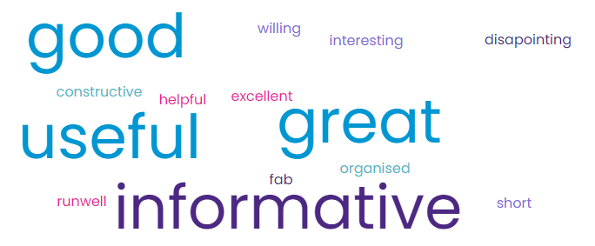
- The sensory OT one was really good. The mental health season was described as with autism and anxiety which I would have liked to have seen, but it was mental health in general. Useful to hear the work done in schools and how it can help get access for 1:1 support for students sooner. That would have been really helpful for us a few years ago
- I attended all workshops and found them all very useful
- FAB - great selection of support that you never get to "see" in person
- Challenging behaviour - felt the slide presentation was abit dry and not interactive. Didn't mention WHY kids present with challenging behaviour/ barley any mention of SEND.
- Mental health autism and anxiety wasn't actually about autism but still some very useful information
- Sensory workshop was absolutely brilliant
- Mental health and autism - was wrongly titiled and didnt include autism
- Good and quick bitesize sessions
- some of it was helpful
- workshops not long enough. Sensory most helpful. maybe to be able to talk to them after and not rushed
- i found it really helpful
- EHCP – a bit disappointing preferred more formal approach
- i attended 3 workshops and all very informative
- attended 3 workshops very interesting and good to take home information to move forward
- Good
- goood
- EHCP workshop really helpful
- excellent
- Good went to benefits in afternoon well run
- good and well organised
- katie george - very helpful and constructive advice, responsive to participants needs
- great and informative EHCP
- i attended sensory workshop and the information was great with a daughter with sensory issues it was more information
- all really great
- Benefits - interesting and informative
mental health and autism was just mental health
- very short but informative
- Challenging behaviour - delivery was dry presentation didn't offer anything additional to leaflet. The content was tailored towards general challenges with behaviour rather that identify triggers for children with potential SEND. Felt like a parenting workshop. did help gain insight to why strategies discussed are having little impact
- managing behaviour - felt it was not interactive enough
- informative and an opportunity to ask questions. looked detailed in places but staff willing to talk to other workshops

- What were your thoughts on the venue? (include ease of getting here and accessibility for your need)
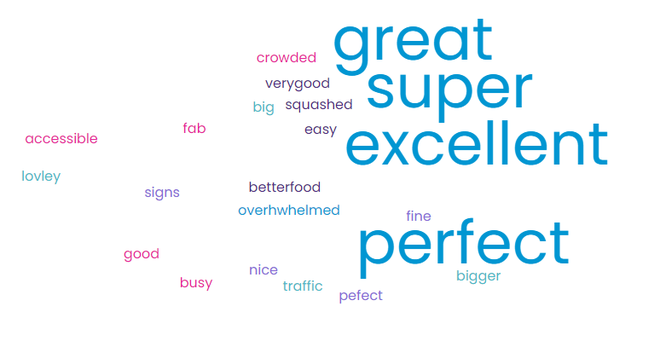

- The venue was accessible and okay. As mentioned previously, the space with the stalls seemed too small to fully get to everyone and was overwhelmed.
- The venue was excellent
- Easy to access
- easy parking
- Ok
- some areas were squashed in
- Perfect
- Very good
- Perfect
- Great venue parking facilities are appreciated. Better food facilities would have been good as advert said there was a cafe? was there?
perhaps abit crowded could there have been more space.
- Could do with better address details
- Great venue
- FAB
- good accessibility. as said before over crowded at times
- very good excellent
- Venue ok
- great for parking but very very crowded a bigger hall would be better
- had to park in far car park so something with better parking would have been helpful
- easy to get to clear instructions within the building and lots of people to help. only negative is the stalls too close together and overwhelming at points
- easy to reach good parking etc. good venue but needed more space in main suite it felt abit crowded at times
- super
- good
- good
- the pcan event was in a separate place but was not easily accessible
- good selection of people/groups to visit
- unsure of where they were
- Good
- Good Parking and nice space
- good. got very busy
- yes
- excellent
- perfect for my needs
- great
- good
- great
- easy to get here and plenty of free parking
- very good
- easy access easy to find and lots of space
- Good location with free parking
- venue great but leeds road is a nightmare
- Easy to get to and well laid out
- good
- very good
- more signs needed at entrance more spaced out as was overwhelming
- good
- easily accessible easy to find
- good
- good
- all good
- great choice of venue
- excellent
- good
- good
- easy to get to but crowded inside
- nice
- good
- great event - poor signage on arrival to car park i went in the wrong building
- all fine
- may need a bigger venue
- very good nice and big
- lovely venue , really hot and needed water canisters
- good
- good but needs more space
- the venue was fantastic maybe make sure of the hospitality boxes
- bigger venue very crowded and loud
- perfect
- good
- enough room
- super venue main room a little congested and over whelming
- Lovely venue just too much traffic
- road works made finding it difficult no signposts as to where to go for the carpark. Staff were very helpful in the venue.
- N/A x9

- Is there anything else you would like to share with us?
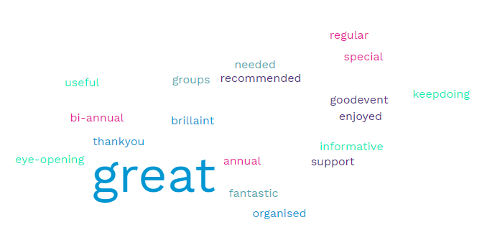
- Thank you for running this event. It's the first SEND event that I have attended and found it usefulness. It would be great for it to happen again, with different workshops and the stall holders again so we could speak to people we didn't get a chance to today.
- Very well organised and informative
- brilliant event thank you so much
- Thank you for running this
- Just that i really enjoyed this event
- same as previous questions
- Generally, a really good event and i have got some good advice.
- Brilliant event great to know the support services out there when you feel alone THANK YOU
- Thank for organising, a great opportunity to get information all in one place would certainly recommend
- i had a great afternoon
- i think it has opened our eyes to how many places exist that we have never heard of. some very quick to pass you on especially kirklees departments EHCP/SEND etc why cant they all be on department. All stall described are branches of each other which is frustrating
- hopefully this becomes annual
- please please keep doing this . the local offer is a much needed service.
- thank you for running this please make it annual or bi annual. Parents and carers NEED this to get through the mind field of information.
- just thank you for putting this together. Super helpful and fantastic idea
- it was good to find out whats out there. Local offer feels confusing/overwhelming as a parent. Good to put faces to names and meet groups.
- need more for younger children more for people who move area, Health visitors to point in right direction
- Tea and coffee would be nice. would love this to be regular Really useful thank you
- really informative and hope it runs again
- events for people with disabilities as young adults 18-30 with employers floating who can offer work experience
- no thanks
- all great
- Thank you very much
- i was expecting waves and shabang to be here
- very good way of doing things lot of information
- all good
- please do another
- thank you so much for this event
- thanks so much
- need on at Batley as Huddersfield too far
- thank you
- thank you for this
- how are events like this promoted to parents who aren't in the "system"
- would have liked to have seen locala health there not just OT
- Be useful to be an annual thing as children age and will need special services/new services as they become available
- No x 3
- N/A x 37

Direct email
“Thanks so much for yesterday. It was a great day and I'm looking forward to watching the videos of workshops I missed.

Could I please make a couple of helpful suggestions for if you hold another (which I really hope you do).

Could you please provide tissues for all stallholders? I had no idea how upsetting I would find it speaking to people and went through the tissues in my pocket in no time. The stallholders were having to go through their own belongings to find one to give to me, which made me even more embarrassed at breaking down in front of them.

Having a space set aside to go if overwhelmed would also be great. I had to hide behind a couple of pull up banners at points when I was very upset.

I watched a couple of presentations and the Benefit's one in particular was extremely challenging to read and I have good eyesight. I'm a head of communications for a XXXXXX and accessibility and inclusion is so important when presenting information, especially given the nature of the event. It might be a good idea to ask any charities who support those with visual impairments to provide your presenters with some guidelines. White text on a coloured background is incredibly hard to see, as is too much information.

Thoughts for next time if helpful:

More gift bags. 😁

A parent's experience as a workshop. To hear someone who has come out of the other side and to hear about their teenager or young adult (If doing well after a difficult time) would be a beacon of hope to many parents, myself included.

Also information on alternative provision for children who are academically capable but cannot cope in a mainstream setting (if it exists) as I know many autistic children who would fit into this category who are falling through the cracks.

It took a lot of courage for me to attend alone yesterday but I'm so glad I did and I'm definitely feeling more hopeful now than I did before.

Well done and thank you!”

Stallholder feedback
Direct emails
- On behalf of myself and X, we wanted to say a massive thank you for having us at the event. We had a great time networking, meeting the local support agencies and families. You also articulated the event brilliantly, superbly organised and made myself and X feel very welcome. I have replied to the feedback on behalf of the DWP and look forward to working with you again in the future.”
- On behalf of X and myself many thanks to all of you for organising and running yesterday’s event – we didn’t sit down all day, we ran out of handouts and didn’t have time to visit many other stands, but we met so many people, had some really interesting and positive conversations and had a GREAT time. Please put our name down for a stand at the next event, whenever that may be.”
- Just wanted to say a BIG thank you to everyone involved in setting up and organising the event today. I was running the Barnardo’s Young Carers Stall and found the day to be really well organised, from the pre emails, right to the day itself. It was well attended and we are grateful to be there and have some visibility for the children and young people we support. THANK YOU.

Feedback forms
We would really like your feedback on how the day went for you? please think about what you learnt as a service, the venue etc.
- I learnt that there needs to be more of these events as a lot of the people we spoke to were not aware of what was out there for them or their family members. The venue was perfect (but i would say we should be allowed to bring our own food/refreshments).
It was really good as a service to be able to speak to other services in person and exchange experiences and contacts.
- Just how much is available for parents
Well attended.
Could we have these events more frequently rather once per year?
- The idea behind the event is amazing. I think parents/carers really value all services coming together so they can easily access them in one place and it has the interpersonal element of putting faces to names.
In terms of venue the signposting was poor with lots of people commenting on the day they had been to the stadium main entrance and the venue on the 3rd floor with a small lift isn’t wheelchair friendly
- I felt the venue was well set out with enough room for people to move while allowing others to talk with people at the tables without getting too squashed. It was a good opportunity to meet face to face with other providers as well as provide advice and support to students, tutors and families alike.
- the day was brilliant. It well organised and there were a great range of providers. There was good attendance and the feedback from parents suggested it was a necessary event that everyone got something from.
- I think it went really well as a new company it was very informative as well as getting a lot of interest from people about our services
- It was a very well attended, comprehensive event that allowed plenty of exposure but also the opportunity to network.
- Overall, I thought the event was huge success, it was great to see such a well-turned-out event, not only agencies but those of schools/providers and parents/carers. The location was great, big enough to house everything but not everyone knew where other stalls were. Access to the first floor was an issue for some people, I understand the lift is only small and those who had wheelchair access struggled to use the lift with their carers as this was not big enough, unfortunately only having one lift at an event that supported SEND young people and families, caused some frustration for them.
- It was a very good day, well planned and well attended. The venue was good, and it was a good networking opportunity.
- The day was fantastic, we had people at our stall constantly all day. We would prefer longer than 30 minutes for a workshop because sensory is a huge topic.
Thanks for having us.
- we have got some contacts out of the event that will be i think very useful. the event was extremely busy. the staff were all very friendly and helped where they could. i managed to get around all the stalls and spoke to the people i needed to. I'm not sure the people that needed me found me as we weren't in the main hall.
- The venue was great, it was able to fit all people in and it was a good outcome compared to other years!
- The venue was fine and we had a very good day! We need to make our offering more obvious to people passing our Stand at future exhibitions
- It was good to see it so well attended by so many parents and carers and it felt like a great space for us to come together in. The opportunity to network with other agencies was fantastic too and is something I feel I really missed over the covid period.
- It was great.
Very well organised and a range of organisations attended.
I was surprised at the number of parents and families who attended.
We also made some good links with other schools and professionals to develop our own practice
- It was a very busy day, unfortunately, I didn't get the opportunity to visit all the stands, but from people I spoke to at the Stadium it was a very informative event and well worth the visit.
- Very good turn out from providers to people advocating for people with additional needs. Best attended event we have been part of this year (we have attended quiet a few this year). Although we are for adults with learning disabilities we still have a lot of people who didn't know about us and didn't know they were entitled to our services. We have since had few referrals through, so our present to this event is valued. So thank you for allowing us to come along.
- Fantastic! Came across some great providers we will be promoting and encouraging parents to access. Larger
- We thought the event was fantastic and well organised. A variety of support agencies and many families attended.
- I thought the event was really good. It was really well attended, and I spoke to lots of people who were very polite and interested to find out more about us. I also had a quick walk around everyone else's stand and again everyone was happy to chat. The event organisers were very visible and happy to help. I thought the room was a good size and comfortable. I did have an absolute nightmare trying to find the right parking though, but I think that was Google maps' fault!!
- Great event- lots of various stalls so good for networking. Lots of service users attending so must have been advertised well. :).
wasn't sure what the workshops were but that was definitely a pull for people.
- My colleague and I had a great day and didn't stop all day! - we were speaking with visitors for the whole day and didn't actually sit down at all! We spoke with many parents, teachers and various service providers as well as quite a few adults with additional needs. We ran out of leaflets and information!
- As a mainstream service it was helpful to be able to speak to parents/carers/families to understand how our service can support families where there are children with additional needs. It was great to hear what works well for them and where we still have some work to do.
The venue seemed to work well for the number of people who attended. From a stall holder perspective free parking, close to the venue was helpful.
It was great to see the event so well attended by both families and professionals.
- Lots of services on offer, great turnout, it was great to engage with so many services and interact with potential and existing service users.
- I think it was a great success for parents to be able to speak to people face to face and ask the questions that the cant get answered usually. Great to see the large number of services that we have in Kirklees for my self as a sign poster but for parents to see that there could be a group or service that can support them during what can be a stressful time.
- It was a great venue, although didn't agree with the food rule i.e. buying theirs only! Especially with it being a SEND event and our interns being unemployed.
- The day was fantastic thankyou so much for organising! Great for networking with other services and was really good to chat to parents about the service. We learnt a lot about perceptions some parents have which aren't necessarily correct and how we need to improve our comms for the new school year.
- Very good, great to be back networking!
Venue ideal was very well attended by parents/carers and professionals.
- It was busy, busy, busy! We talked to so many different people from other services but most importantly service users and potential service users. It was great to showcase all our libraries have to offer. The venue was fine in that there was plenty of parking and is central to Kirklees. It did however get very loud in the main hall and often it was hard to hear what people were saying.
Is there anything we could do better next time or change?
- No
- I wonder if the venue could be split across more rooms. A few parents said they felt overwhelmed by the sheer number of stalls. Could services be grouped by need? EG All health together, all education etc?
- Accessibility. Free refreshments for staff holders
- Having previously attended an event where providers had access to hot drinks I was surprised to see there was only tap water on offer, with a small cup of coffee costing £2.40. I could understand a one off cost and then having access to refreshments but it was very expensive and I am tempted to bring a flask for the next event.
- Possibly more of these events
- The event was lovely, but costs of refreshments were very pricey.

- Although I liked the venue, location with ground floor space would be an advantage. I know that the Textile Centre was used in previous years and worked well for SEND Clients.
Tea & coffee facilities - it would of be great had these been available from 8.30.... also, hot drinks were rather expenses for £2.40 for an instant coffee was rather steep.
- Possibly the catering could have been better for the stallholders.
- Longer workshops - 45 minutes if possible.
- there were 3 of us in a corner, in a corridor ( Growing works, No limits and Endorphins.) We were not on the natural traffic path so I feel we missed out on a lot of people that could've benefitted from our services. there was also not enough room between our tables for a wheelchair and as a SEND event this should not of happened. my biggest complaint would be about the food and drink. It was not permitted to take our own food and drinks on to the premises, for us to then get there to find a very small cup of coffee ( that I would've expected to be around 90p) was £2.40, there were sugar cubes left out on the bar, there was a large black hair running through them when I told the staff they took the hair out but did not replace the sugar. then to pay £5.50 for a sandwich, these prices were so over inflated and i found this dreadfully unfair as the event was marketed as a send event meaning mostly charities were there and we are not known for having loads of money, we were already paying 2 members of staff and then had to spend more on the food.
- would be good to involve more young people in the day who may access the services
- Provide us with a little more space
- Cheaper tea and coffee
- My only criticism would be on your details email for the day it stated, 'no food or drink to be brought into the Stadium as there would be refreshments available on the day to purchase', therefore I didn't bring my lunch and had to buy a sandwich which I though was extremely expensive and not really very nice. I later found out there was a cafe in the building that had a better variety of food and not as expensive.
- due to the amount of providers who attended it did feel very cramped but that could be due to the volume of people attending, of which you could not of pre-empted, also the price of refreshments for everyone was not expected, of which a lot of providers mentioned they didn't take that into account, therefore went without all due to not been offered anything.
- Larger coffee options....and that is seriously nit picking because the event was a clear success!
- From our perspective, link ins with your local Job Centres to attend e.g. Work Coach/Disability Employment Advisor, as there were many questions around Universal Credit, Employment Support Allowance etc. Also, we myth busted around making links with job centres, even if not looking for work, they are there to support people who are not work ready also!
- No, we were grateful to be allowed to come last minute and that you were flexible with our availability. Thank you!
- would be good to share contact details of all stall holders so can contact if didn't get a chance to speak to them on the day.
- To be honest the coffee wasn't great! but other than that, I thought the event, communication around the event and venue was really well organised. Thank you so much, we hope to be able to take part again at a future event.
- Only one small thing - not being able to bring own food/drink and then having to pay £2.40 for a cup of coffee felt a bit much. Didn't detract at all from the day though!
- Would have preferred to have been informed that we were working on the 3rd floor to allow for easier set up/close down. Not being permitted to bring food/drink - especially considering the prices, quality and portion sizes of drinks/food on offer and at an event for vulnerable people and charities. I presume this was a stadium requirement, but it was not appropriate for this event and felt unreasonable. Our stall set up was away from the 'main hall' meaning we felt rather left out from the main buzz and our space became very crowded, very quickly due to the narrow space which impacted how many people we could talk to. We had to a shut door to try and direct people to us, as due to the setup, people were missing our stall. As we were situated within a narrow space, the table set up generally felt quite squashed in especially if more than one or two people wanted to interact at each stall in our area and it could only fit one wheelchair through meaning everyone had to move out the way each time ta wheelchair user wanted to move through, and it felt like accessibility had not been fully considered in our space. Food and drink and general resources for the stadium were being transported through here regularly which kept disrupting our discussions and meaning everyone had to move out the way each time a food or drink trolley was being wheeled through it also.
- One of things I wanted to pick up is that I think the heading of our workshop was incorrect and some parents were left frustrated by this - rightly so - Rosa didn't have a title and so we didn't cover the subject of anxiety and Autism. One suggestion would be to have leaflet of strategies to help parents with dealing with say anxiety, low mood, emotional regulation etc so that they also have some concrete things to try at home that can benefit them. To support the cost of these could be displayed and a photo could be taken of said document.
- As above but otherwise, a fantastic event. Thank you Sammy.
- Where our table was at the top of the stairs - this created a bit of a blockage in terms of people at the top of the stairs. We also did a lot of directing and stewarding people around - it would maybe be useful to have an information desk there.
- No I felt as a service it went very well, had great feedback from other services too. Hopefully putting the word out regarding our free services, we offer too will help some SEN parents!
- Refreshments! £2.40 for a small instant coffee! I appreciate that it was the venue that set the tariff but it seemed exploitative especially as it was such a wet day and people were reluctant to venture out. Luckily I had brought my lunch and water bottle so I was OK.
- No x 2
- N/A

Young people’s feedback via Project Search
- Very popular and busy
- Loads to offer with variety of companies
- Hands on services like growing your own organic food
- The hosting was fabulous
- More accessible (visual impairment)
- More fun times / less boring times – more interactivity on stalls / tombolas / raffles
- More local schools
- Fundraising for special needs
- Arrange for group bookings to make it less overwhelming
- Promote more support groups
- Less expensive food and drinks
- Big venue
- More special needs service users
- Over a few days e.g. weekend
- More health / medical companies
- More companies / careers fairs

Who would you have like to have seen there?
- Homosystinuria – specialist for the condition
- Luv 2 Meet U
- Jubilee Centre (social groups)
- Freeman College Fusion café
- Brian Jackson Centre
- St John Ambulance
- More NHS services
- Folly Hall
- Dogs Trust for visual impairment
- Cannon Hall Farm
- Our Yorkshire Farm Amanda Owen

