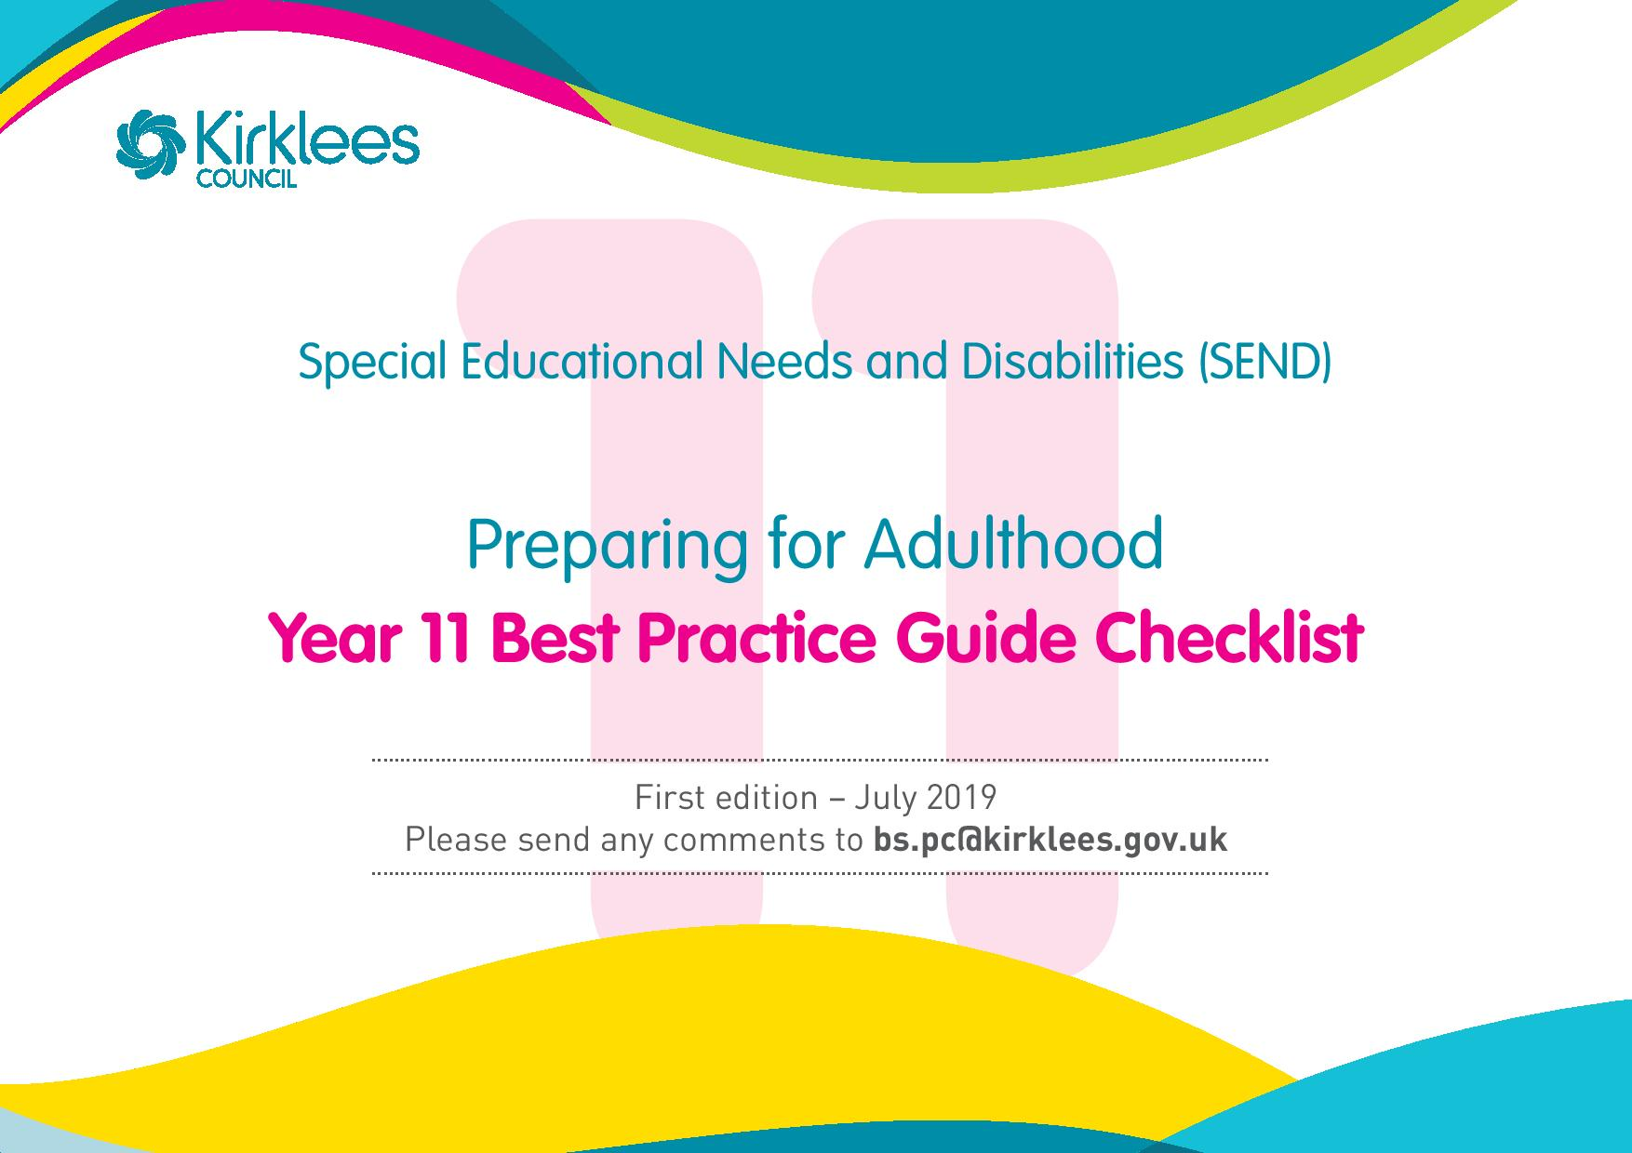

Who is it for?
This best practice guide is a checklist for professionals supporting young people, and their parents, to plan and prepare for adulthood.
Why has it been developed?
To help ensure professionals, young people and parents have the right information at the right time to make informed decisions and help all parties prepare and plan effectively for adulthood.
When does preparing for adulthood start?
Planning will formally start in year 9, there is a lot to start to think about. Year 10 and 11 focus on developing future plans and monitoring progress. From 16 years of age choices and decisions need to be made.

Who should be involved?
SENACT named Officer Child/young person Calderdale &Kirklees Careers Parent
Social Worker (if involved) School Other key professionals actively involved in the person’s life

Year 11

EHC Review Meeting
Ensure that any relevant post 16 providers have been invited. Consider/re-consider any mental capacity issues.

Ensure the meeting captures all the information, outcomes and actions that enable the child/young person to move towards being as independent and possible and being able to participate in society.

Consideration should be given to whether an EHC plan needs to remain in place post 16 in order for education and training outcomes to be met (EHC plans do not remain in place for social care and health outcomes only).

Discuss any healthcare and social care needs.

All professionals who are involved in supporting the child/young person should attend the review meeting and or provide advice to support the setting of outcomes and planning provision.

Education and employment – views and aspirations

1. | Ensure the personal profile reflects current goals and aspirations for education and employment. This is supported by information, advice and guidance as detailed below.
2. | Use life skills sessions to ensure an informed understanding of all their options making sure high aspirations are considered.
3. | Students may want experience beyond what is included on course. Support students to find appropriate work experience: C&K Careers have a work experience team that can help with this.
Notes:

Being independent – views and aspirations

1. | Ensure the personal profile captures views and aspirations in relation to being independent.
2. | Ensure opportunities are in place to develop the key skills to become as independent as possible, for example travelling independently, managing your own money, life skills.
3. | Help the child to make decisions about how to achieve long term independent goals.
4. | Make clear the choices and options available, providing the right information and ensuring a referral is made for example for travel training a referral should be made to the community enablement team, my life team.
5. | Ensure the child can make their own decisions whenever possible and understand what support is available to help them to be as independent as possible, for example using an independent advocate, see web page for the advocacy services available www.kirklees.gov.uk/advocacy
Notes:

Being as healthy as possible – views and aspirations

1. | Discuss what being as healthy as possible means to the young person and families, for example pain management, how to maintain and develop good health, maintaining and improving mobility.
2. | Discuss current healthcare needs and provision. Discuss how and when the young person will move from children’s health services to adult health provision (See transition planning section.)
Notes:

Participating in society – views and aspirations

1. | Ensure the personal profile captures views and aspirations in relation to participating in society.
2. | Ensure opportunities are in place to enable the child’s interests and hobbies to continue, for example, through sports, social activities, etc.
3. | Help the child to make decisions about how to spend free time and ensure appropriate support is in place.
4. | Agree ways to stay safe in the community.
5. | Agree how to maintain friendships when the child leaves school and develop opportunities to make new friends.
6. | Help the child to understand the choices and options available, providing the right information to enable them to make informed decisions.
7. | Ensure the child can make their own decisions whenever possible and understand what support is available to help them to be part of their community when they leave school.
Notes:

Information and advice
1. | In advance of the Year 11 review, the Careers Adviser produces an EHC plan specific Careers Summary with the young person, which includes: The voice of the young person; their aspirations; short, medium and long term SMART outcomes; evidence of guidance (where the young person has the capacity to understand) and the young person’s preferences of post-16 provision.
2 | The EHC plan specific Carers Summary is included in the Year 11 review and then attached to the Head Teacher’s report for passing on to SENDACT.
3. | Careers Adviser ensures that all pupils apply for a suitable post 16 option, and that all pupils meet the September Guarantee of a place in learning.
4. | C&K Careers SEND team meets regularly during Year 11 with Kirklees SENDACT team to facilitate smooth transition to post 16 provider with timely consultations.
5. | Young people and families are supported and reassured over the summer holidays ahead of starting their post 16 provision.
6. | C&K Careers support in completing transport and bursary application forms.
7. | C&K Careers attends Parents Evenings / events.
8. | C&K Careers assists with Work Experience placing when required
9. | Reinforce all advice and guidance listed in year 9 and reinforced in year 10. More focussed conversations will need to take place where a social worker is involved specifically around eligibility criteria for adult social care.
10. | Home of my own brochure and planning tools; http://www.kirklees.gov.uk/beta/learning-disabilities/pdf/HomeOfMyOwn.pdf
11. | Autism passport https://www.autism.org.uk/hospital-passport
12. | Vulnerable In Patient - VIP Scheme and Hospital passport are schemes to support you to make sure health services are able to meet your needs if or when you go in to hospital.  www.kirklees.gov.uk/beta/learning-disabilities/health-care.aspx
13. | It is important to understand the implications of the Mental Capacity Act regarding decisions about the young person’s health.  http://www.careengland.org.uk/sites/careengland/files/Mental%20Capacity%20Act%202005%20easy%20read%20guide.pdf  https://councilfordisabledchildren.org.uk/sites/default/files/field/attachemnt/making-decisions-_easy_read_-_opg605-1207.pdf
14. | Has consideration been given to completing a Continue Healthcare funding checklist?

Transition planning
1. | Create opportunities for students to meet key college staff either in school or college and opportunities for students to familiarise themselves with key areas of the college.
2. | Develop confidence around travelling to college as appropriate.
3. | Ensure that the student and their family are clear about the study programme and are developing plans for the other two days if necessary.
4. | Agree with the enablement team the specific support required from them, for example, travel training, life skills development, etc.
5. | Check if the parent visited their GP who can help with the transition to adulthood. It is important the child and families get to know their GPs if they are not already.
6. | Check if the child went to their GP for an annual health check if they are on the learning disability register held at their GP.
7. | Is the parent aware of the Ready Steady Go programme, which provides a guide to help and support people to meet their health needs?
8. | Check if the lead health professional, who is the most appropriate to coordinate and communicate with the family and other health professionals, has been identified?
9. | Has the parent been informed by their paediatrician when their transfer of care will take place? Paediatricians will transfer at an appropriate age, normally from 16 years of age onwards.
10. | Discuss and agree actions around physical health, mental health and staying as healthy as possible and the responsibility of the child and family.

