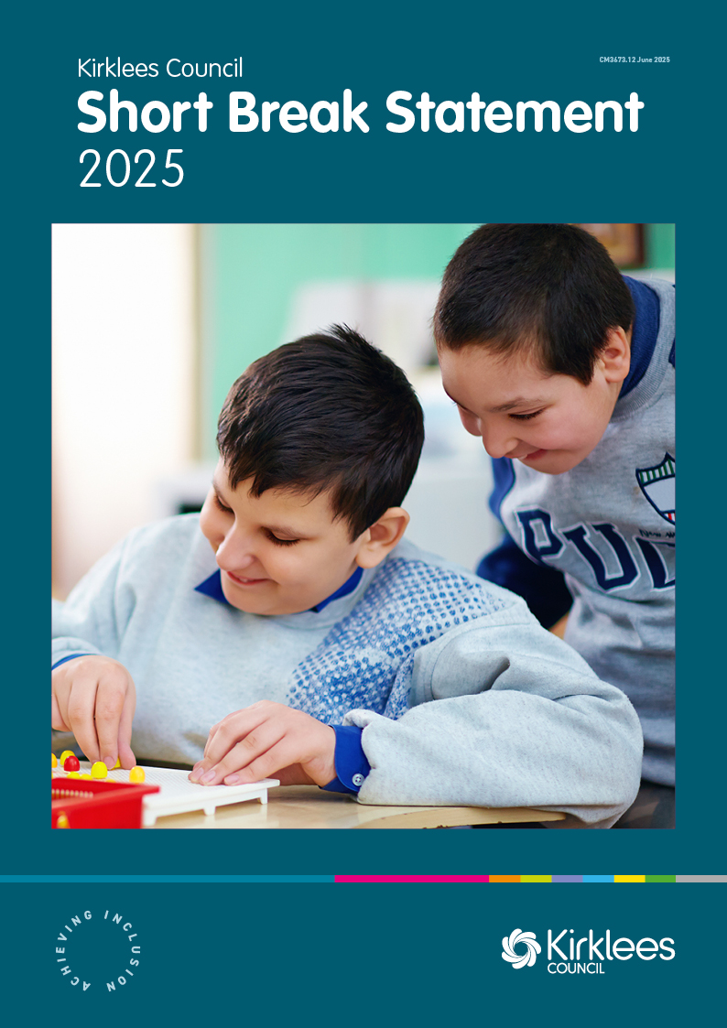

Table of Contents
1 Introduction 1
2 Jargon Buster 1
3 What is a Short Break? 1
4 Activities and services available to families 1
4.1 Universal activities: 2
4.2 Targeted activities 2
4.3 Specialist activities 2
5 Removing barriers to accessing and activity 2
6 Making sure activities and services meet your child’s and their family’s needs 2
7 How do we know what parents, carers and young people want? 3
8 Review our Short Breaks Statement 3
9 Jargon Buster 3
10 Useful links to information 4

Introduction
All children, like to have fun, make friends, and take part in activities without their parents or carers. This also gives parents and carers a chance to take a break.
Kirklees Council aims to ensure there are activities for children with Special Education Needs and Disabilities that are available at the right place and time.

Jargon Buster
We try to make the information we give to parents, carers, and children easy to understand. But if we must use difficult words, we have a ‘Jargon Buster’. This can be found at the end of this statement.
You may also want to have a look at the following Jargon Buster, which might help you when looking at other documents produced by the council and health colleagues.
Jargon Buster (A-Z) Kirklees Local Offer

What is a Short Break?
A short break is an activity that a child with Special Education Needs and Disabilities can take part in, giving parents and carers a break from looking after them.
These activities can be different. Some you can just go to, while others might need an assessment of your needs to access them.
All families with a child aged 0 to 18 who has Special Educational Needs and Disabilities can get an assessment.
A short break can be anything from joining a community activity to getting overnight support.

Activities and services available to families
There are activities to meet everyone’s needs. These activities are usually called universal, targeted, or specialist.
To find out which activity is best for you and your child, please have a look at our Local Offer. It tells you about the activities, who runs them and how to join. It will also let you know if you need an assessment or if you need to meet any eligibility criteria to take part in them.

Universal activities:
These are things like your local community football team or drama group. You can usually just talk to the person who runs the club about what you need to do to join and what support your child needs.

Targeted activities
These are like universal activities but have more staff to make sure your child is supported. You might need to give information about your child’s needs, usually through an online form.

Specialist activities
These are for children who need extra help to join in. Support could include a 1:1 worker to help your child, activities with skilled staff, or overnight support at home or in a setting away from the family home.

Removing barriers to accessing and activity
If your child has trouble joining activities, there is support to help. Please have a look at our Local Offer for what support is available.

Making sure activities and services meet your child’s and their family’s needs
Kirklees Council funds many activities and services for families of children with
Special Education Needs and Disabilities.
To make sure these activities and services meet the needs of local families,
Kirklees Council checks if they:
- Offer choice.
- Give children with Special Education Needs and Disabilities the chance to feel empowered.
- Provide places that meet the needs of children with disabilities.
- Support children with communication and medical needs.
- Are available in different places and at different times.
- Include children with disabilities, even when behaviour that challenges might be a barrier.
- Have staff who understand the needs of children with disabilities.
- Give good, timely, and easy-to-read information about the activities.

How do we know what parents, carers and young people want?
Kirklees Council listens to parents, carers and children when developing activities and services. By understanding their experiences, we aim to create activities that meet their needs. We work closely with PCAN (Parents of Children with Additional Needs) and our two Special Education Needs and Disabilities children’s groups to make sure everyone has a voice. We may also carry out online surveys to hear from more parents and carers about specific issues.

Review our Short Breaks Statement
Kirklees Council regularly checks our Short Break Statement to see if its correct and will change it when needed.
22/04/25

Jargon Buster
- Activities: Fun things children can do.
- Activity Provider: A person or group that runs an activity.
- Assessment: A way to find out what support you need.
- Carer: Someone who helps look after your child without being paid, like a family member or friend.
- Children with a Disability Service: A team that helps families of children with disabilities by figuring out what support they need.
- Community: A group of people who live in the same area or have something in common.
- Community Plus: A team in the council that helps families join activities.
- Disabled: A term for someone who has a condition that affects their thinking, learning, senses, or physical abilities.
- Education, Health, and Social Care: Different types of support for children and families.
- Eligibility Criteria: The rules that decide if you can get a service.
- Inclusive: Where everyone feels welcome and can join in.
- Local Authority: The organisation responsible for public services in an area.
- Participation: Taking part in an activity or decision.
- PCAN: Parents of Children with Additional Needs, a group for parents and carers of children with extra needs.
- Provider: Someone who offers a service or activity for children with disabilities.
- Short Breaks: Activities that give families a break from caring for a child with a disability, different from school or childcare.
- Short Break Statement: Information about who can get short breaks, what is available, and how to access them.
- Targeted Activities: Activities designed for children with disabilities.
- The Local Offer: Information about services available for children, young people, and their families in Kirklees.
- Universal Activities: Activities that all children can join.
- Unmet Needs: Things that stop you from doing everyday activities.

Useful links to information
The Local Offer
Local Offer Activity Information
Children with a disability service eligibility criteria
PCAN – Parents of Children with Additional Needs

